**SULIMO JOINT MOCK**

*Kenya Certificate of Secondary Education.*

**565/1 BUSINESS STUDIES Paper 1**

**July 2024 – 2 hours**

**Name:** …………………………………………......................………… **Adm No.:** ……………… **Class** …………..

**Candidate’s Signature**: ………………………………... **Date**: ………………………………………

**Instructions to Candidates**

1. *Write your name and index number in the spaces provided above.*
2. *Sign and write the date of the examination in the spaces provided.*
3. *Answer* ***all*** *the questions.*
4. *All answers must be written in the spaces provided in this booklet.*
5. *Do not remove any pages from this booklet.*
6. ***This paper consists of 8 printed pages.***
7. ***Candidates should check the question paper to ascertain that all the pages are printed as indicated and that no questions are missing.***

**For Teacher’s Use Only**

|  |  |  |  |  |  |  |  |  |  |  |  |  |  |  |
| --- | --- | --- | --- | --- | --- | --- | --- | --- | --- | --- | --- | --- | --- | --- |
| 1 | 2 | 3 | 4 | 5 | 6 | 7 | 8 | 9 | 10 | 11 | 12 | 13 | 14 | 15 |
|  |  |  |  |  |  |  |  |  |  |  |  |  |  |  |

|  |  |  |  |  |  |  |  |  |  |
| --- | --- | --- | --- | --- | --- | --- | --- | --- | --- |
| 16 | 17 | 18 | 19 | 20 | 21 | 22 | 23 | 24 | 25  **TOTAL**  **MARKS**  **M** |
|  |  |  |  |  |  |  |  |  |  |

1. Define the following terms: (4 marks)
2. Scarcity

….…………………………………………………………………………………………………………………………………………………………………………………………………………………

1. Opportunity cost

….…………………………………………………………………………………………………………………………………………………………………………………………………………………

1. Scale of preference.

….………………………………………………………………………………………………………………………………………………………………………………………………………………….

1. Choice

….………………………………………………………………………………………………………………………………………………………………………………………………………………….

1. Highlight four circumstances under which a manufacturer would not require a lot warehousing facilities. (4 marks)
2. ….…………………………………………………………………………………………………………………………………………………………………………………………………………….
3. ….…………………………………………………………………………………………………………………………………………………………………………………………………………….
4. ….…………………………………………………………………………………………………………………………………………………………………………………………………………….
5. ….…………………………………………………………………………………………………………………………………………………………………………………………………………….
6. Outline four features of labour as a factor of production. (4 marks)
7. ….……………………………………………………………………………………………………………………………………………………………………………………………………………..
8. ….……………………………………………………………………………………………………………………………………………………………………………………………………………
9. ….…………………………………………………………………………………………………………………………………………………………………………………………………………….
10. ….……………………………………………………………………………………………………………………………………………………………………………………………………………
11. Highlight **four** benefits of using mobile money transfer services as means of payment. (4 marks)
12. ….…………………………………………………………………………………………………………………………………………………………………………………………………………….
13. ….…………………………………………………………………………………………………………………………………………………………………………………………………………….
14. ….……………………………………………………………………………………………………………………………………………………………………………………………………………
15. ….……………………………………………………………………………………………………………………………………………………………………………………………………………..
16. State the source document and journal that deals with each of the following types of transactions.

(4 marks)

|  |  |  |  |
| --- | --- | --- | --- |
|  | **type of transaction** | **source document** | **journal** |
| A) | Credit sales |  |  |
| B) | Returns of goods by customers |  |  |
| C) | Credit purchases |  |  |
| D) | Return of goods to suppliers |  |  |

1. State **four** benefits associated with the construction of the Standard Gauge Railway ( SGR ) to the Kenyan economy. (4marks)
2. ….……………………………………………………………………………………………………………………………………………………………………………………………………………
3. ….…………………………………………………………………………………………………………………………………………………………………………………………………………….
4. ….……………………………………………………………………………………………………………………………………………………………………………………………………………..
5. ….……………………………………………………………………………………………………………………………………………………………………………………………………………..
6. Highlight **four** channels of distributing locally manufactured products in foreign markets.(4marks)
7. ….……………………………………………………………………………………………………………………………………………………………………………………………………………
8. ….……………………………………………………………………………………………………………………………………………………………………………………………………………
9. ….…………………………………………………………………………………………………………………………………………………………………………………………………………….
10. ….…………………………………………………………………………………………………………………………………………………………………………………………………………….
11. The following details were extracted from the Books of Simsim for the year ended 30th April 2006.

Capital as at 30th April 2006 sh. 720, 000

Drawings for the year sh. 50, 000

Additional investments sh. 340, 000

Profit sh. 80, 000

Determine Simsim’s capital on May 2005 (4 marks)

1. On May 1st 2023 the cash of Masomo Traders showed cash and bank balances of Sh, 15,000 and

Sh. 147,000 respectively. Transactions that took place during the month were as follows:

(4 marks)

May 3: cash sales Sh. 120,000.

May 11: paid sh.7,500 cash in respect of wages

May 16: received a cheque of sh. 250,000 from a debtor

May 26: withdrew sh.250,000 from bank for office use

May 29: paid sh.97,000 cash to a creditor

1. The National income is measured using the expenditure approach as Y = C + I + G +(X - M). State what each of the following letter represents. (4 marks)

C: ……………………………………………………………………………………………………

I: ……………………………………………………………………………………………………

G: ……………………………………………………………………………………………………

(X-M) ………………………………………………………………………………………………

1. State **four** documents used in home trade under inquiry stage. (4 marks)
2. ….……………………………………………………………………………………………………
3. ….…………………………………………………………………………………………………….
4. ….……………………………………………………………………………………………………
5. ….…………………………………………………………………………………………………….
6. Kuria is a small scale retailer. Outline **four** considerations he needs to make before he advances gooods on credit to Kamau his friend (4 marks)
7. ….…………………………………………………………………………………………………………………………………………………………………………………………………………….
8. ….…………………………………………………………………………………………………………………………………………………………………………………………………………….
9. ….……………………………………………………………………………………………………………………………………………………………………………………………………………
10. ….…………………………………………………………………………………………………………………………………………………………………………………………………………….
11. Situma insured his maisonette worth sh. 800,000 for sh. 700,000 and unfortunately the house was destroyed by an inferno and he sustained losses worth sh. 600,000. Calculate the amount of money that Situma should claim from the insurance company as compensation and comment. (4 marks)
12. Outline **four** characteristics of a good entrepreneur. (4 marks)
13. ….…………………………………………………………………………………………………………………………………………………………………………………………………………….
14. ….…………………………………………………………………………………………………………………………………………………………………………………………………………….
15. ….……………………………………………………………………………………………………………………………………………………………………………………………………………
16. ….……………………………………………………………………………………………………………………………………………………………………………………………………………
17. Moi Girls School Nairobi trustees would like to build a new administration staff offices. Outline **four** reasons why you would advise them to establish an enclosed office layout. (4 marks)
18. ….……………………………………………………………………………………………………………………………………………………………………………………………………………
19. ….…………………………………………………………………………………………………………………………………………………………………………………………………………….
20. ….……………………………………………………………………………………………………………………………………………………………………………………………………………..
21. ….…………………………………………………………………………………………………………………………………………………………………………………………………………….
22. Outline **four r**easons why a business organization may decide to amalgamate. (4 marks)
23. ….…………………………………………………………………………………………………………………………………………………………………………………………………………….
24. ….……………………………………………………………………………………………………………………………………………………………………………………………………………
25. ….……………………………………………………………………………………………………………………………………………………………………………………………………………
26. ….…………………………………………………………………………………………………………………………………………………………………………………………………………….
27. Highlight **four** circumstances under which downward communication would be appropriate in an organization. (4 marks)
28. ….…………………………………………………………………………………………………………………………………………………………………………………………………………….
29. ….…………………………………………………………………………………………………………………………………………………………………………………………………………….
30. ….……………………………………………………………………………………………………………………………………………………………………………………………………………..
31. ….…………………………………………………………………………………………………………………………………………………………………………………………………………….
32. Kenya is the main exporter of tea in the international market. State **four** ways in which the government of Kenya may increase the export volume of the tea. (4marks)
33. ….……………………………………………………………………………………………………
34. ….……………………………………………………………………………………………………
35. ….……………………………………………………………………………………………………
36. ….……………………………………………………………………………………………………
37. State whether the following factors causes a shift in demand or supply (4marks)

|  |  |  |
| --- | --- | --- |
|  | Statement |  |
| A) | Changes in consumers income |  |
| B) | Cost of production |  |
| C) | Changes in technology |  |
| D) | Seasonal changes |  |

20 Study the figure below and answer questions that follow. 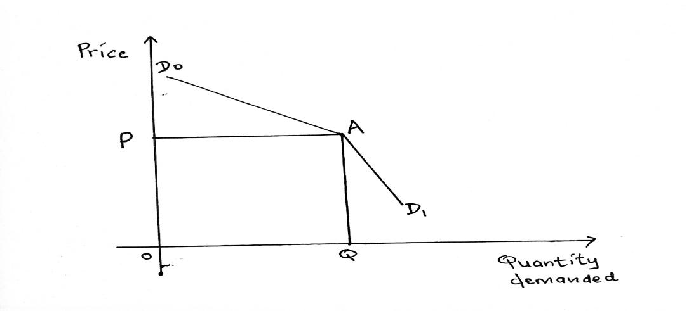

(a) Name the curve above. (1 mark)

....................................................................................................................................................................

(b) State the market structure that experiences this kind if demand curve. (1 mark)

.....................................................................................................................................................................

(c) What P represent in the curve above? ( 1mark)

......................................................................................................................................................................

(d) State one reason why a demand reduces when prices are increased above P. (1mark)

......................................................................................................................................................................

21. Identify **four** challenges that a country with high population of ‘’Gen-Zs’’ is likely to face. (4marks)

1. ….……………………………………………………………………………………………………
2. ….……………………………………………………………………………………………………
3. ….……………………………………………………………………………………………………
4. ….……………………………………………………………………………………………………
5. Mention **four** levels of inflation that a country may experience. (4 marks)
6. ….…………………………………………………………………………………………………….
7. ….……………………………………………………………………………………………………
8. ….……………………………………………………………………………………………………
9. ….……………………………………………………………………………………………………
10. Highlight **four** factors that are likely to hinder development in the third world countries. (4 marks)
11. ….……………………………………………………………………………………………………………………………………………………………………………………………………………
12. ….…………………………………………………………………………………………………………………………………………………………………………………………………………….
13. ….……………………………………………………………………………………………………………………………………………………………………………………………………………
14. ….…………………………………………………………………………………………………………………………………………………………………………………………………………….

24. State the business environment described below. (4 marks)

**Description**

1. Business environment. ………………………………………………………………………………..
2. Affect buyer’s purchasing power. …………………………………………………………………….

(c) Methods used in production of goods and services……………………………………………………

(d) Formal organization of activities for achievement of goals ………………………………………….

25. Outline **four** factors that may make a firm find it necessary to carry out its operations near the source of raw materials. (4 marks)

1. ….……………………………………………………………………………………………………
2. ….……………………………………………………………………………………………………
3. ….……………………………………………………………………………………………………
4. ….……………………………………………………………………………………………………………………………………………………………………………………………………………..